Tutorial 1>>>>>#Install ide🡪visual studio code from link : <https://code.visualstudio.com/download>

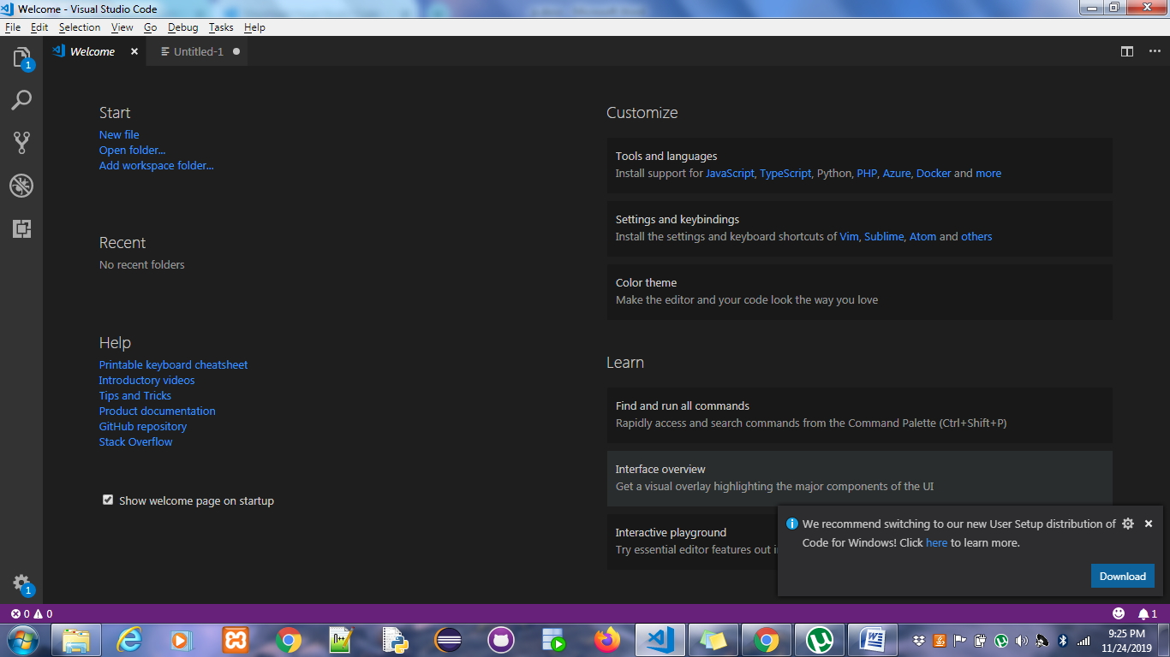

1st Tutorial hello world

Click on new file and create helloWorld.html file

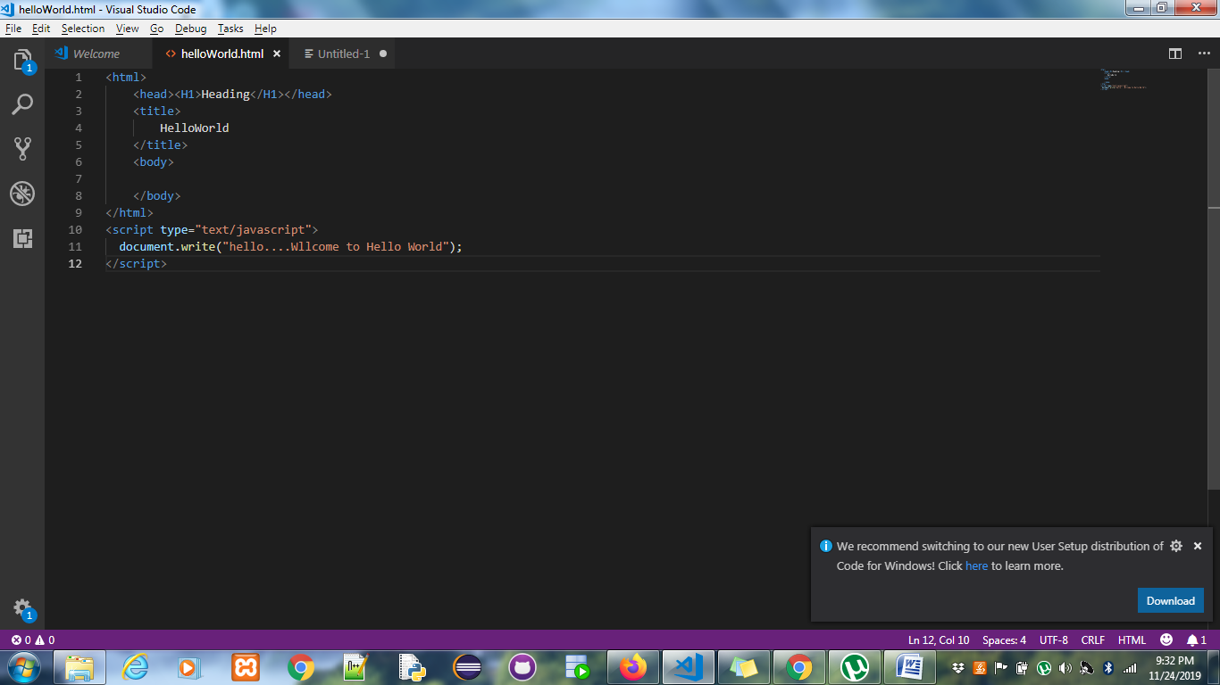

Use code snippet

<html>

<head><H1>Heading</H1></head>

<title>

HelloWorld

</title>

<body>

</body>

</html>

<script type="text/javascript">

document.write("hello....Wllcome to Hello World");

</script>

Out put on browser

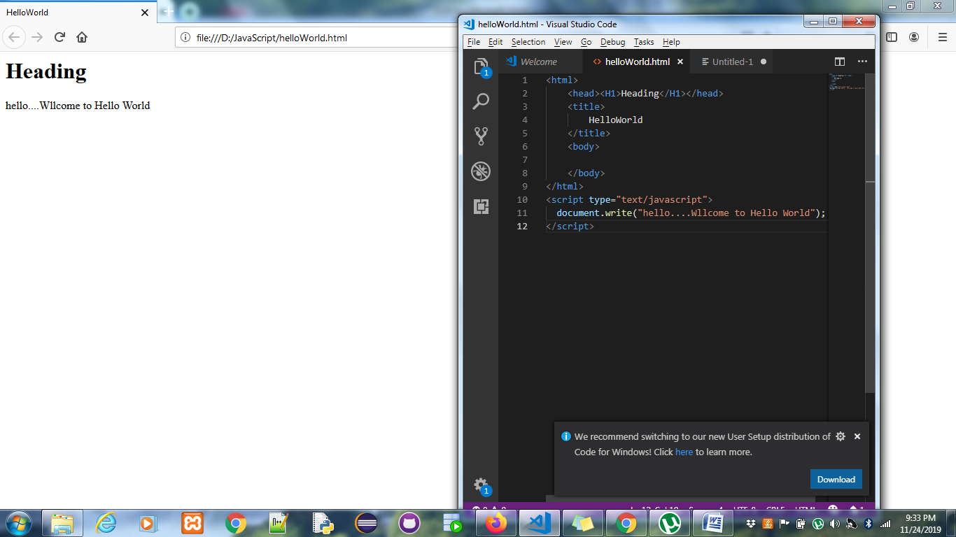

Embedding the external js file into DOM

